**Salesforce Supported SmartInternz Virtual Internship Program Cohort-3-Salesforce Developer 23 Aug to 20 Oct 2023**

**Document for Additional Guided Project**

**“Implementing CRM For Result Tracking of a Candidate with Internal Marks”**

**Submitted By**

**Name: Sandhya Balasaheb Jadhav**

**Email:** [**sandhyajad202@gmail.com**](mailto:sandhyajad202@gmail.com)

**Smartinternz Id (SBID): SB20230683338**

**Date: 12/10/2023**

* **Created Salesforce Developer Org**
* **Custom Objects**

1. Semester Object
2. Candidate Object
3. Course Detail Object
4. Lecturer Details Object
5. Internal Results Object
6. **Semester Object**

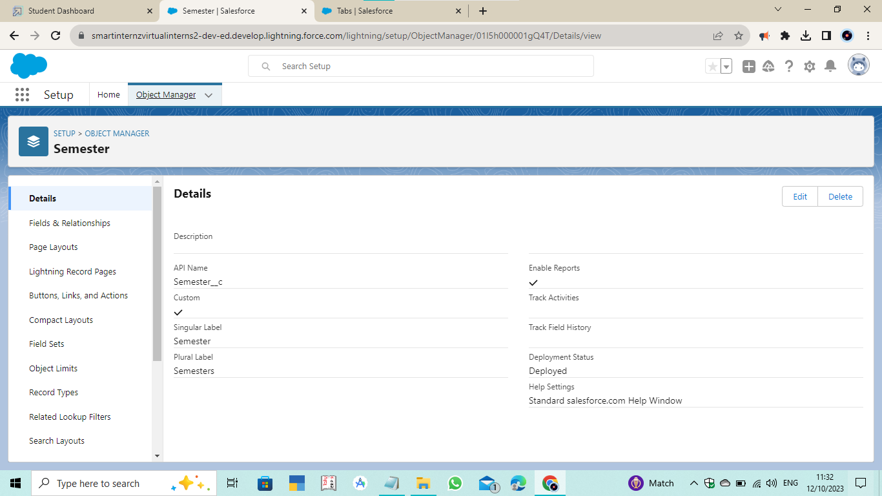

1. **Candidate Object**

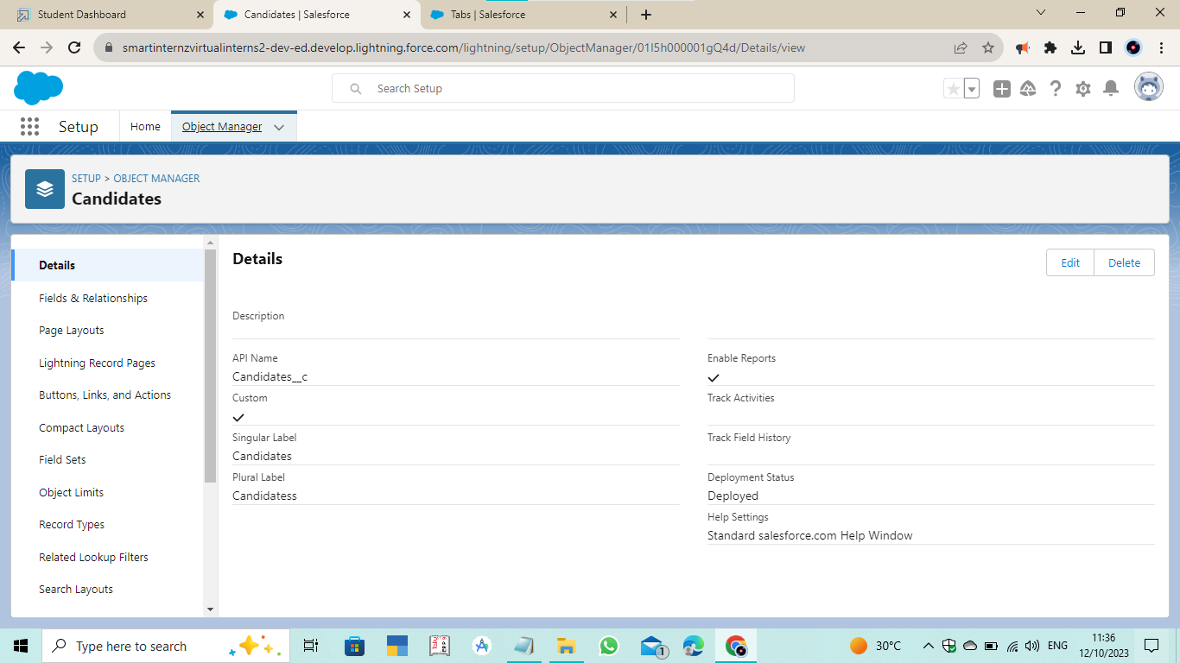

1. **Course Detail Object**

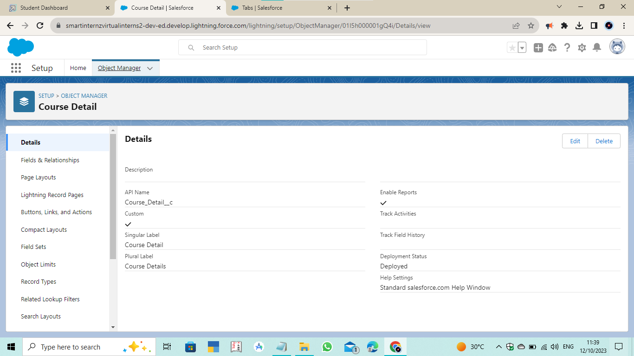

1. **Lecturer Details Object**

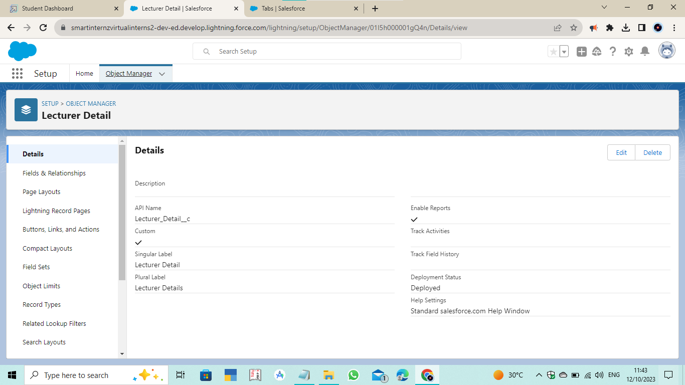

1. **Internal Results Object**

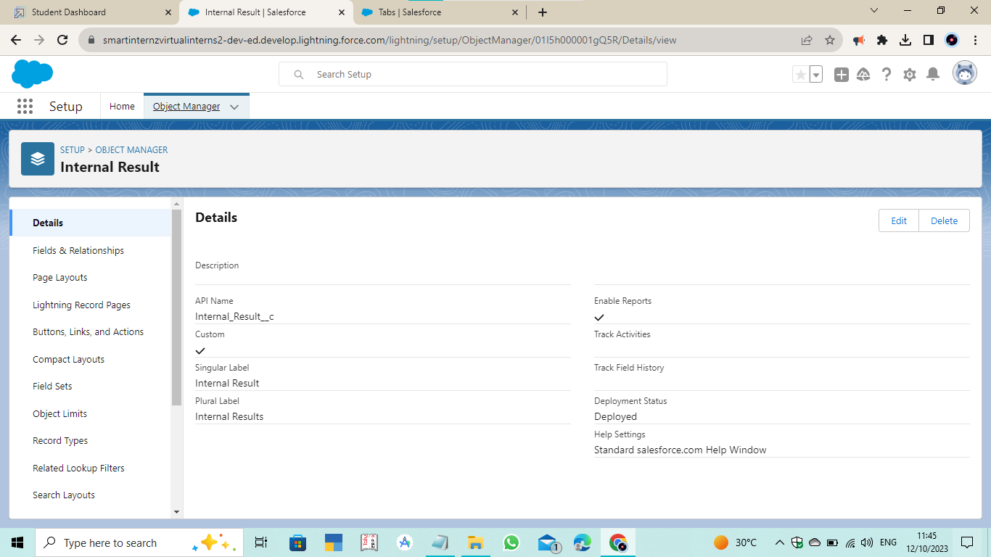

* **Tab**

1. Semester Tab
2. Candidate Tab
3. Course Detail Tab
4. Lecturer Details Tab
5. Internal Results Tab
6. **Semester Tab**

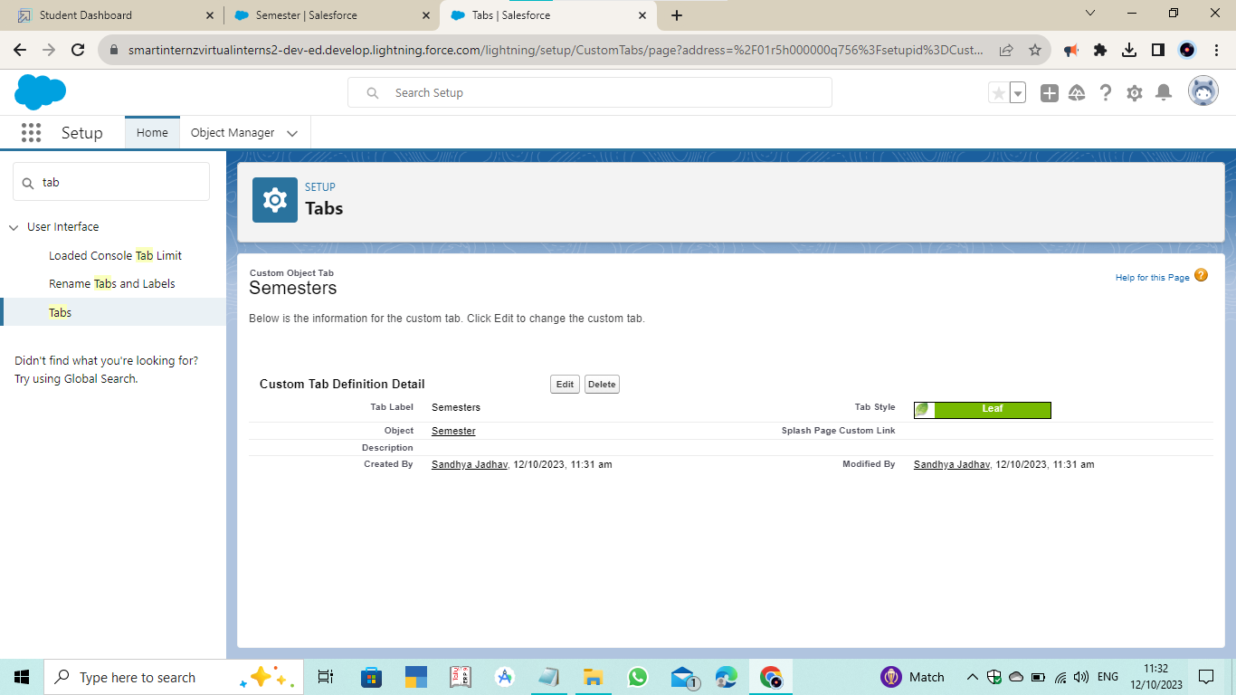

1. **Candidate Tab**

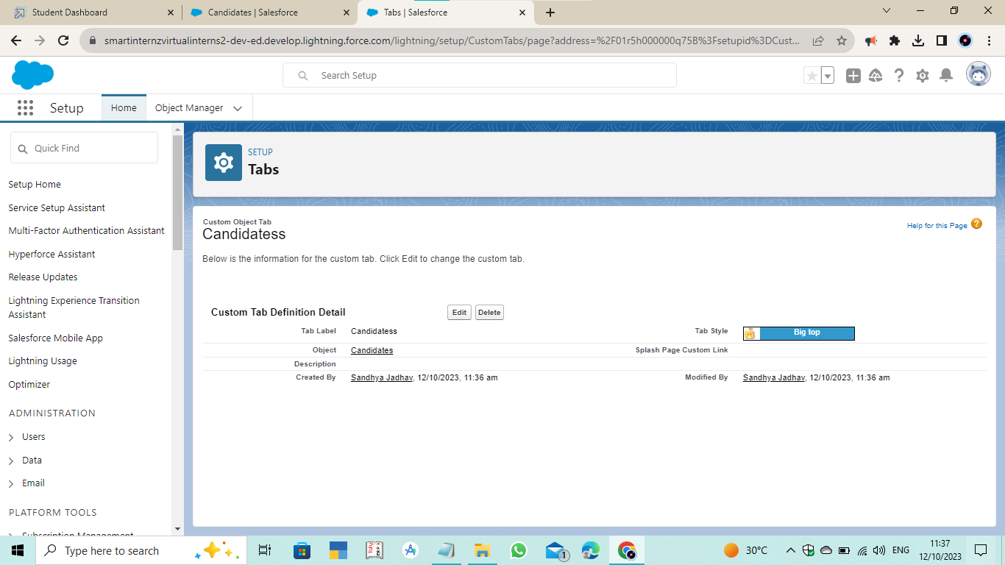

1. **Course Detail Tab**

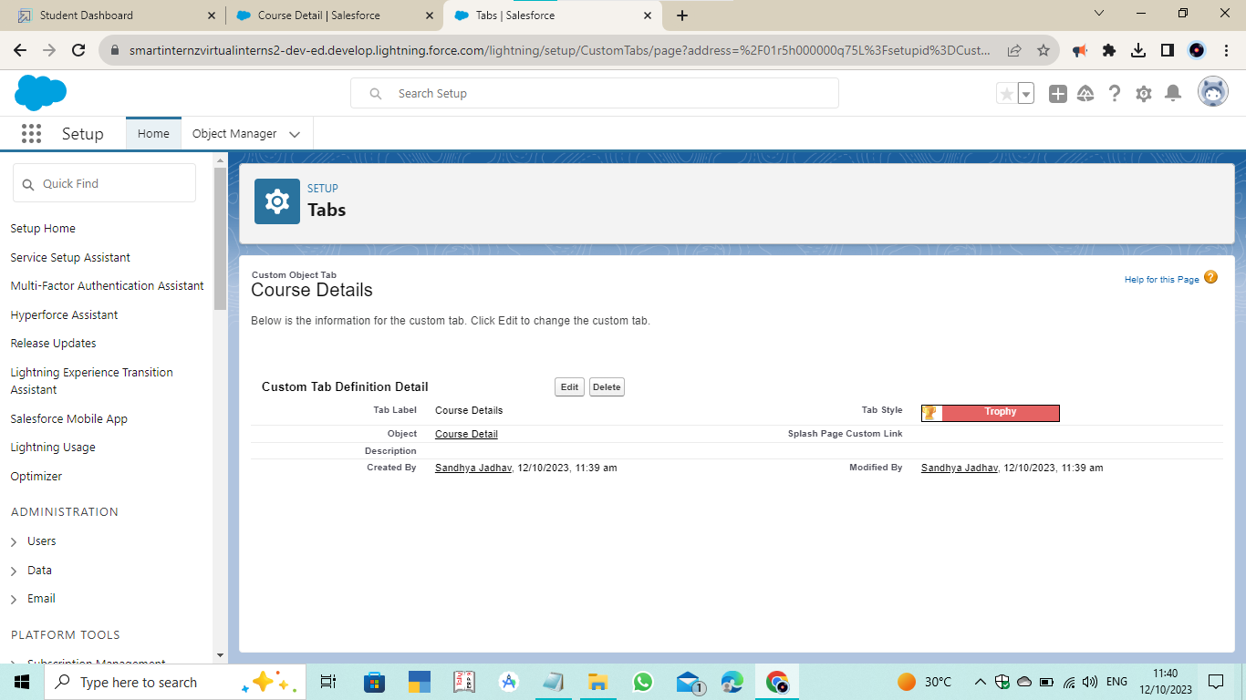

1. **Lecturer Details Tab**

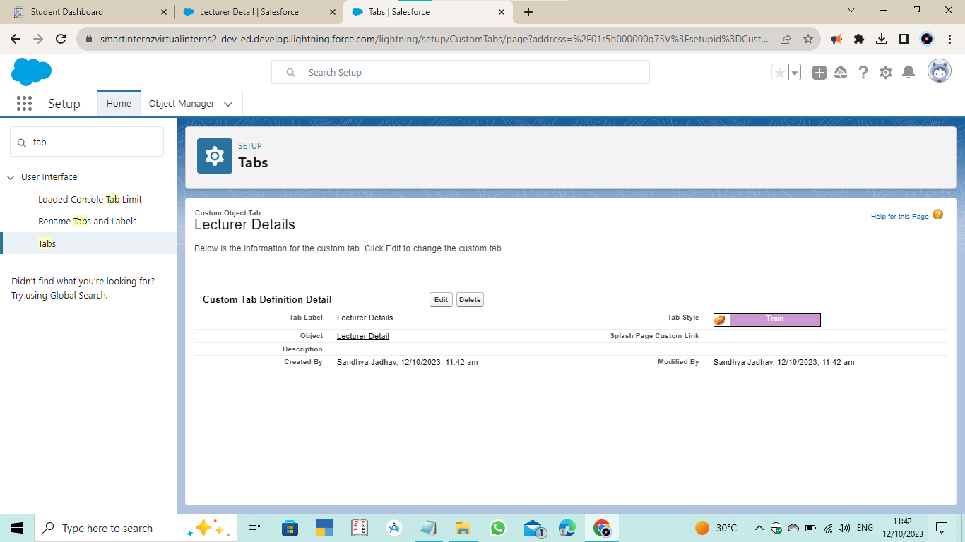

1. **Internal Results Tab**

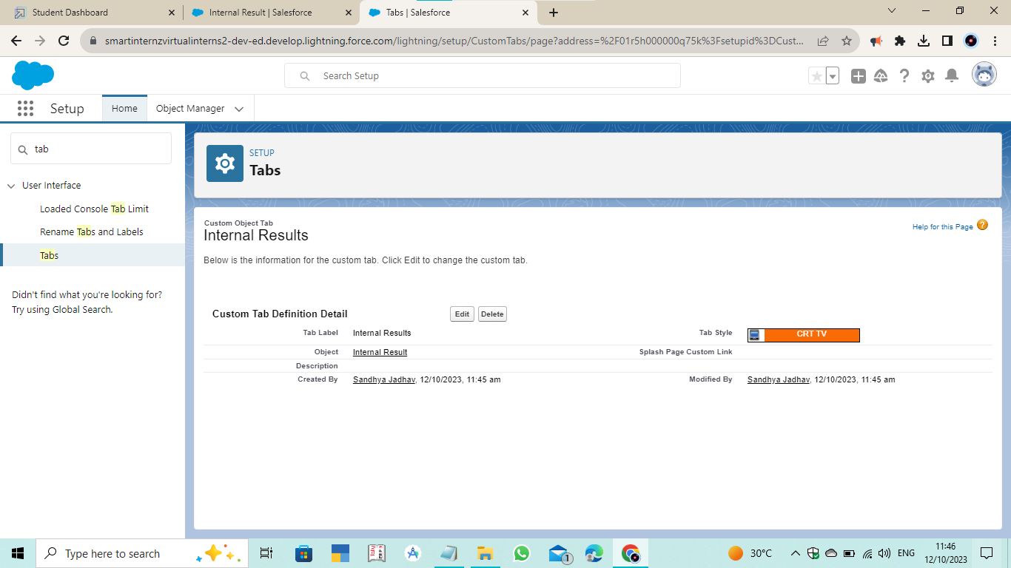

* **Created Candidate Internal Result Card App**

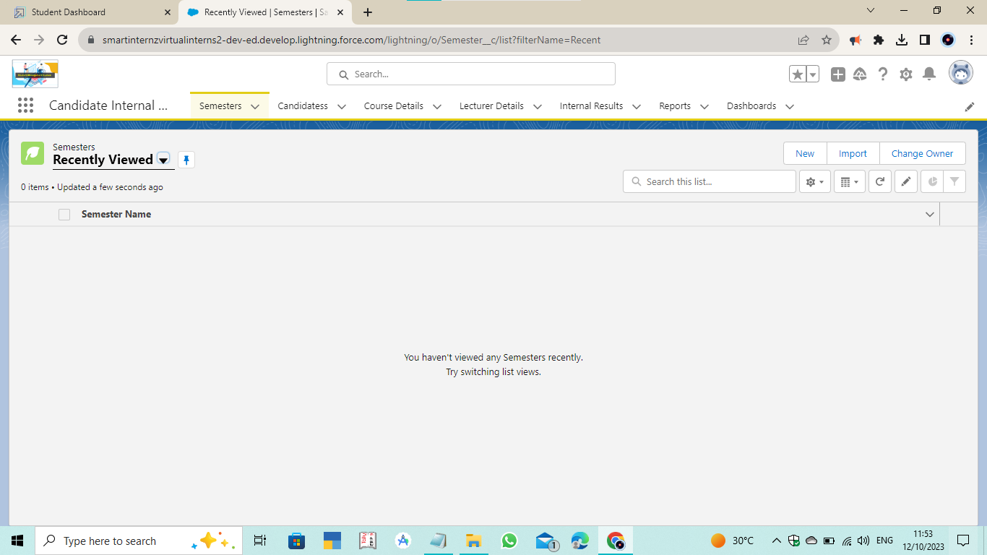

* **Fields and Relationships**

1. **Created Fields on Semester Object**

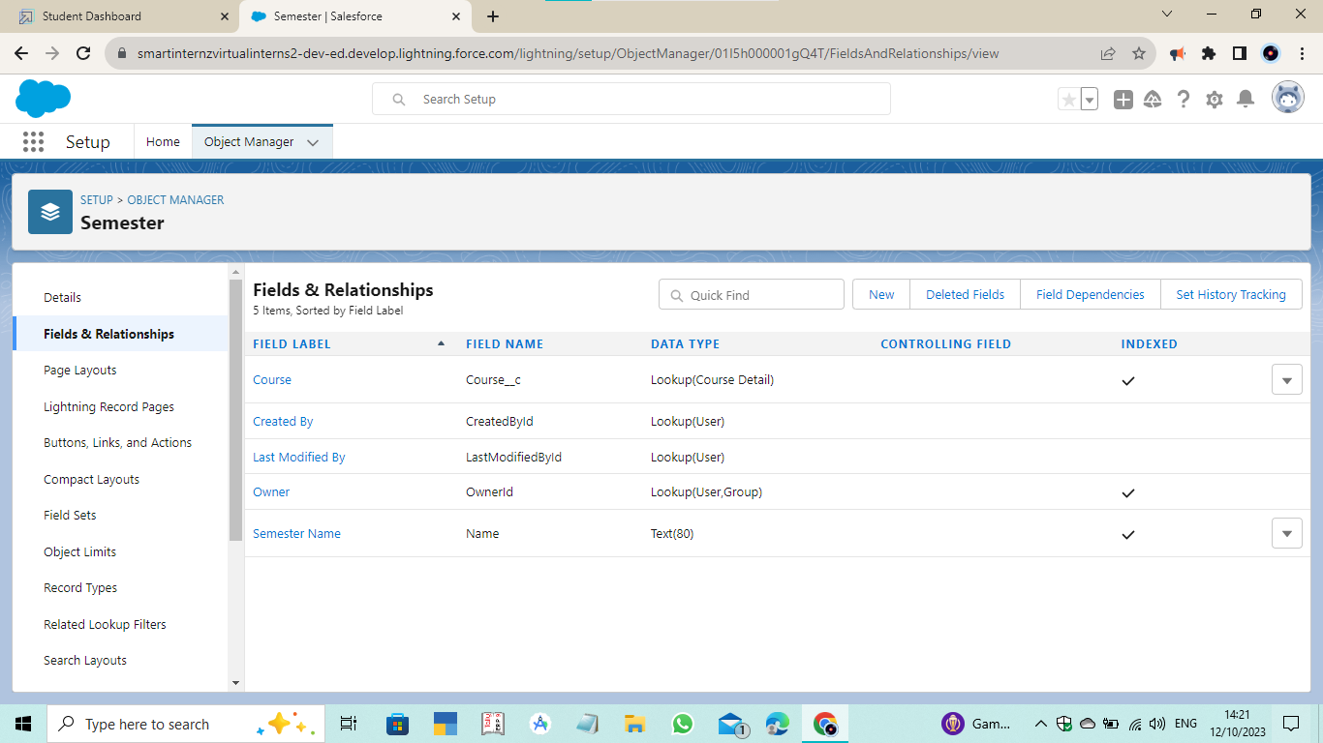

1. **Created Fields on Candidate Object**

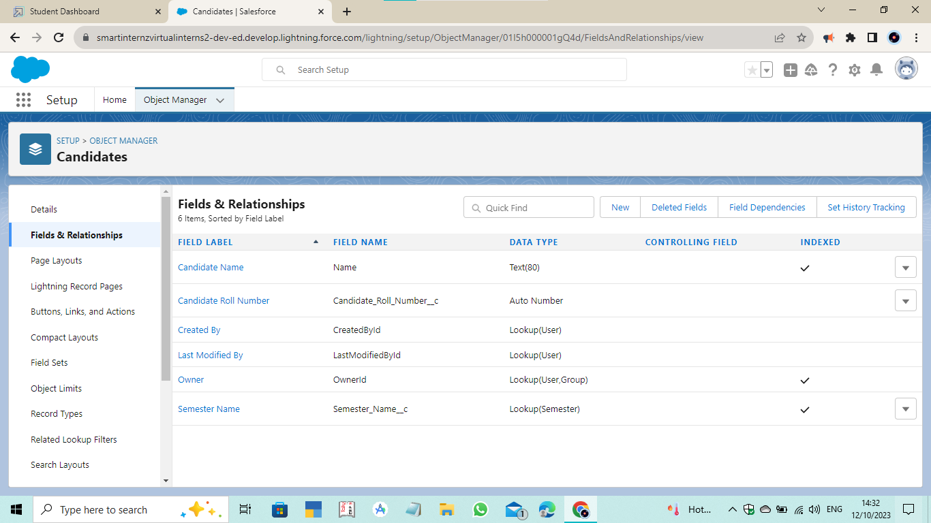

1. **Created Fields on Course Detail Object**

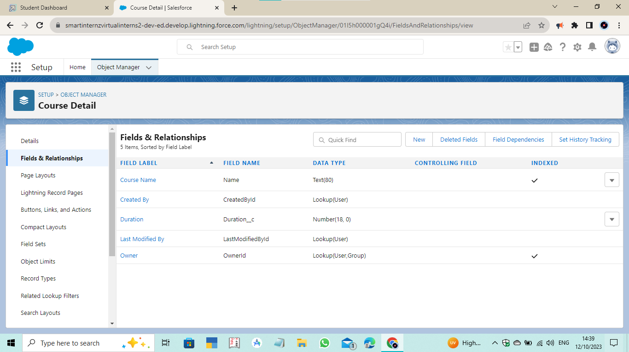

1. **Created Fields on Lecturer Detail Object**

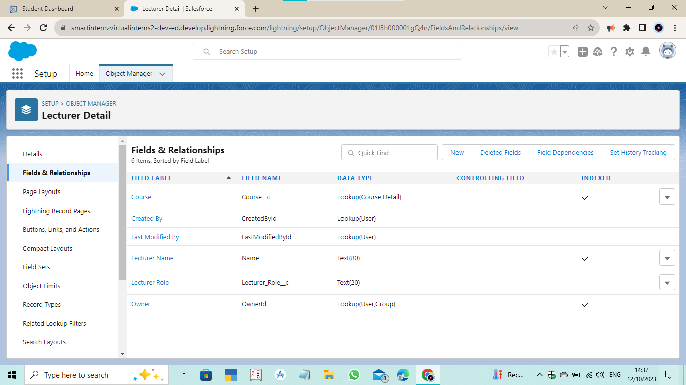

1. **Created Fields on Internal Result Object**

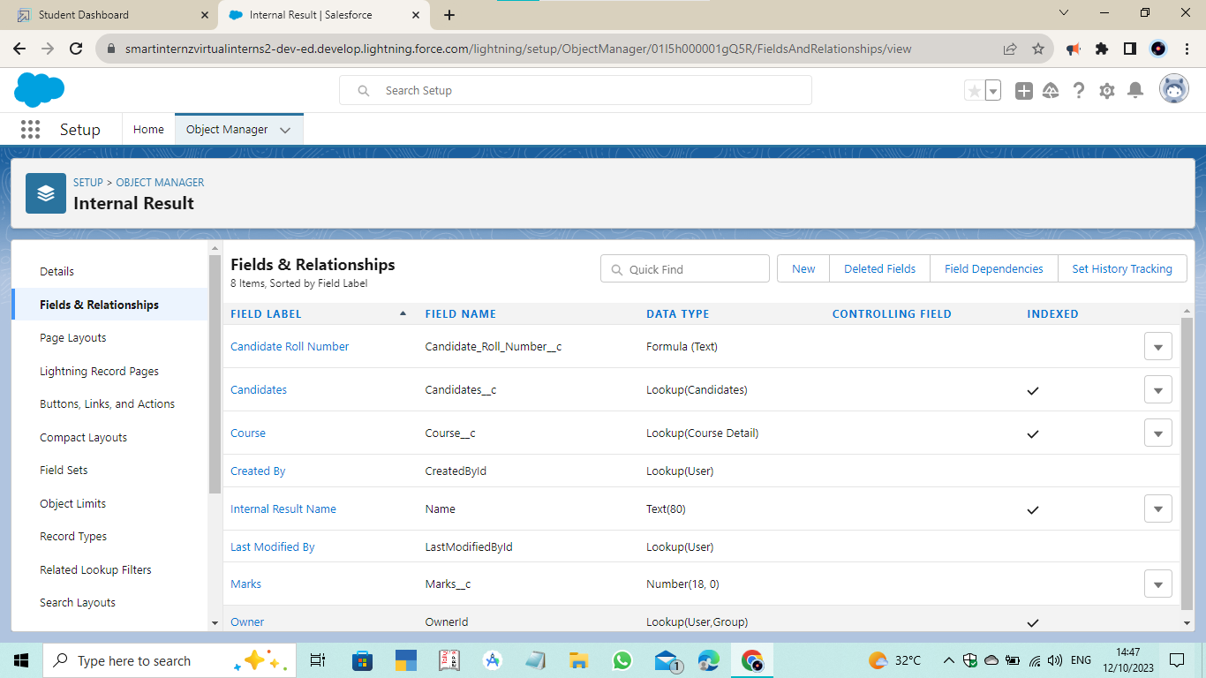

* **Created User**

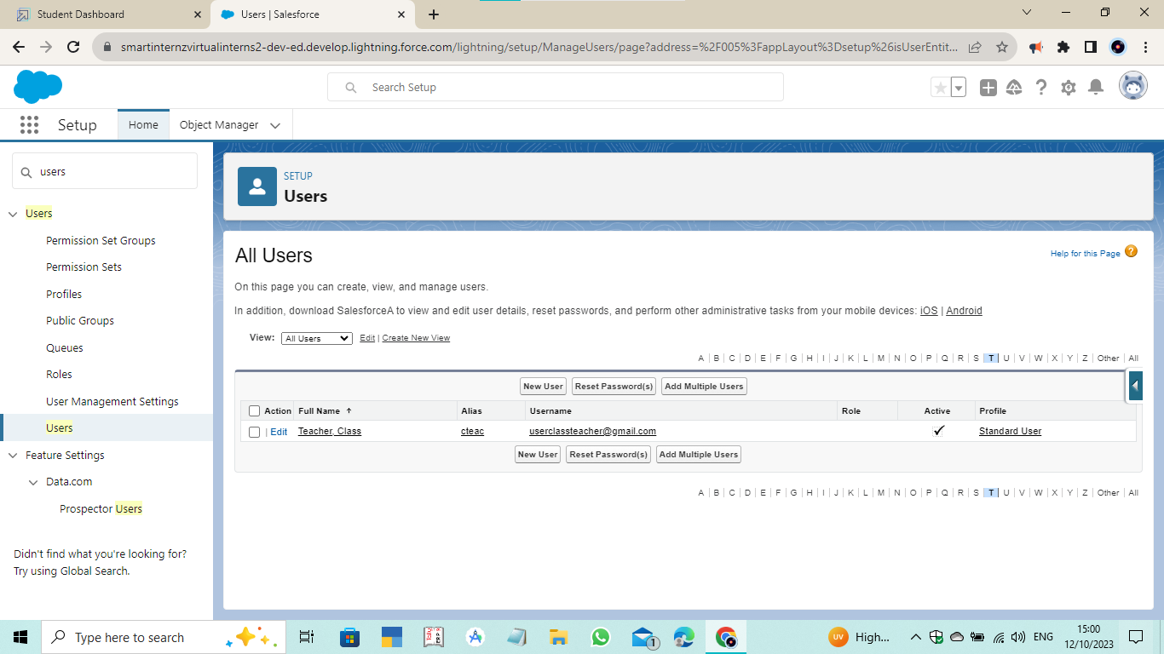

* **User Adoption**

1. **Created Record on Course Detail Object**

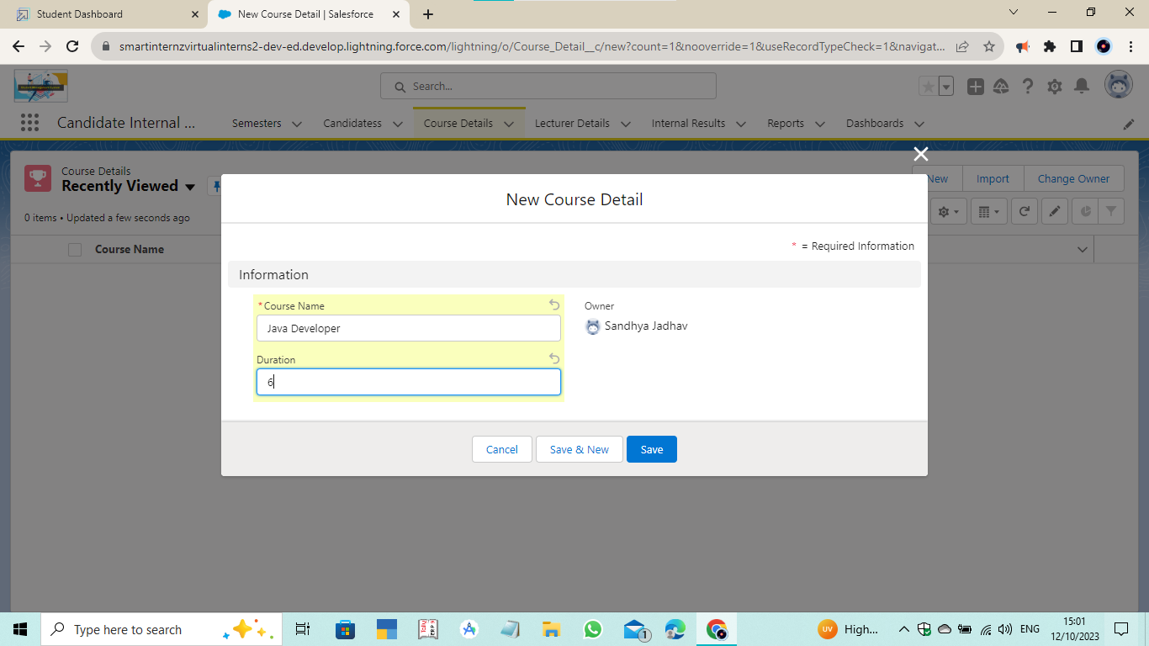

1. **Viewed Record on Course Detail Object**

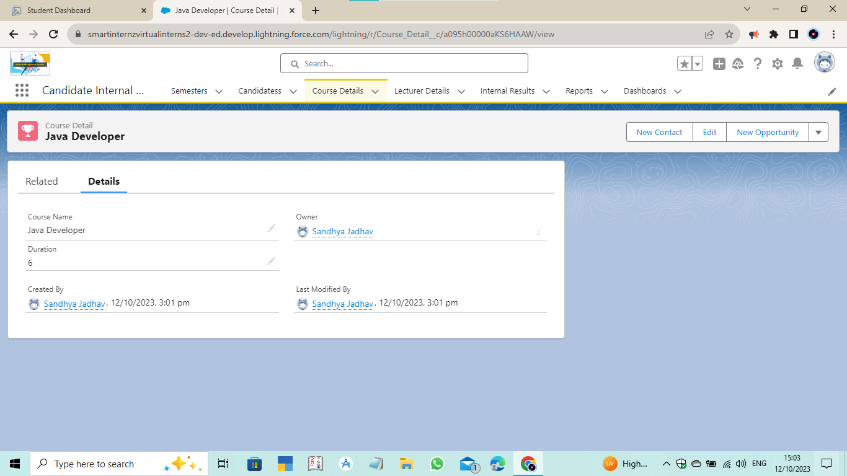

1. **Deleted Record on Course Detail Object**

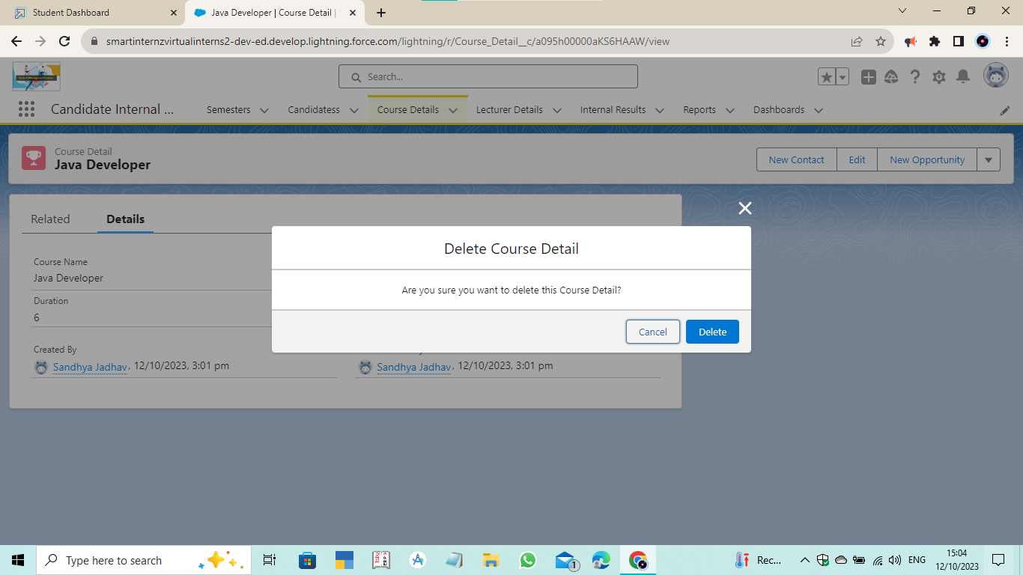

* **Created and Viewed Report**

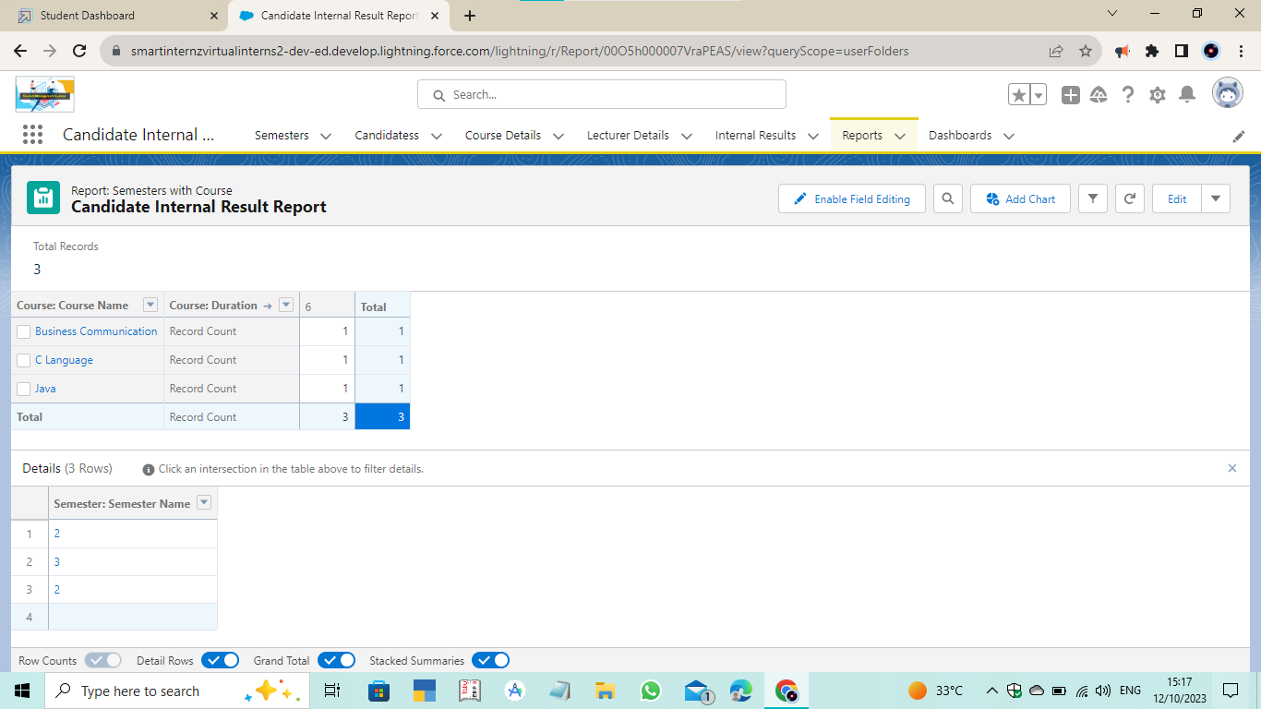

* **Created and Viewed Dashboard**

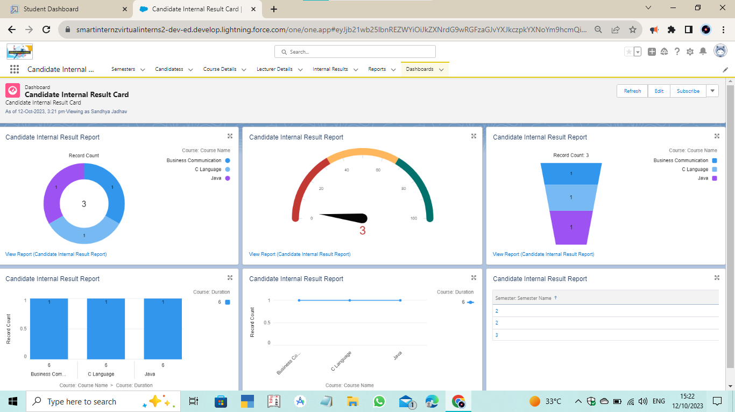

* **Created Screen Flow**

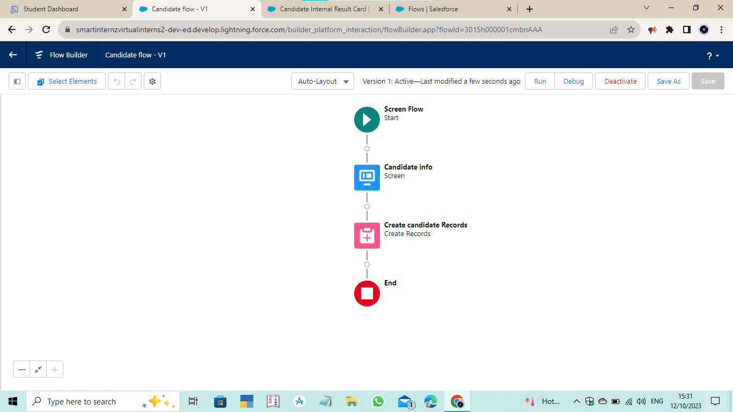

* **Created App Page**

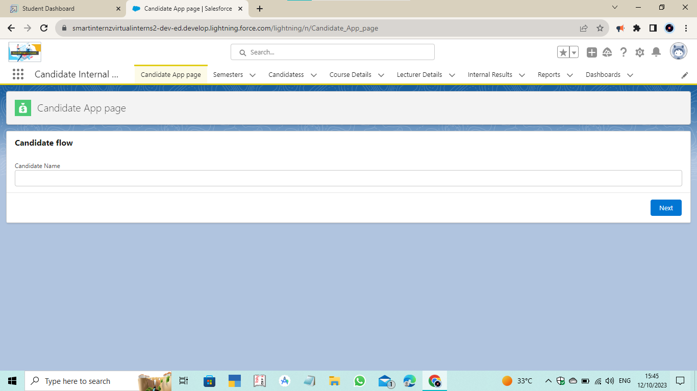

* **Created Apex Class**

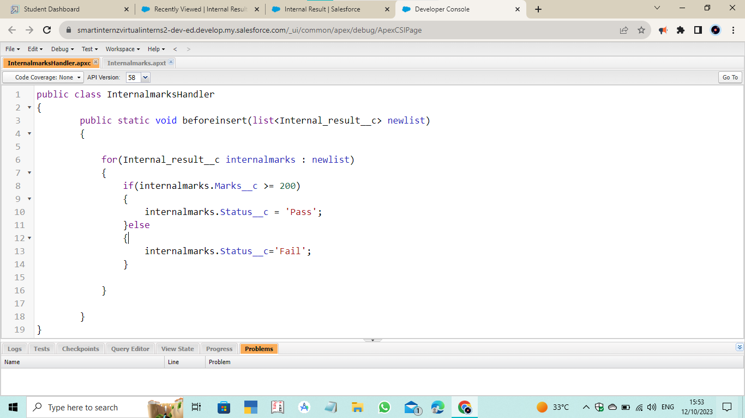

* **Created Apex Trigger**

